PHASE 4 – PROJECT PLANNING
Introduction:
- The Project Planning phase defines the activities required to implement the automated Standard Laptop procurement process.
Based on the project reference document, the implementation is divided into three main milestones:
1. Milestone 1 – Flow
2. Milestone 2 – Flow Assignment
3. Milestone 3 – Service Catalog
The activities under these milestones provide a structured approach for creating the Flow, assigning it to the Standard Laptop Service Catalog item, and testing the request and approval process.
Project Planning Approach:
- The project is planned as a sequence of connected activities.
- First, the required Flow is created using ServiceNow Flow Designer. The Flow contains a Service Catalog trigger and a Create Catalog Task action.
- Next, the created Flow is assigned to the Standard Laptop Service Catalog item through the Process Engine configuration.
- Finally, a Standard Laptop request is placed through the Service Catalog and the approval process is completed. The generated Catalog Task is then checked to verify the configured information.
The planned sequence is:
- Flow Creation → Flow Assignment → Service Catalog Request → Approval → Catalog Task Verification
Milestone 1 – Flow: The first milestone is the creation of the Flow required for the Standard Laptop process.
Activity 1 – Create Flow:
The following activities are planned for creating the Flow:
1. Open ServiceNow.
2. Open Flow Designer under Process Automation.
3. Select New → Flow.
4. Enter the Flow Name as Standard laptop task.
5. Select Global as the Application.
6. Select System user as the Run User.
7. Submit the Flow.
8. Add a trigger.
9. Select Service Catalog as the trigger.
10. Add an action.
11. Select Create Catalog Task.
12. Configure the Requested Item Record.
13. Configure the short description.
14. Add the description field.
15. Select Hardware as the Assignment Group.
16. Select Approved for the Approval field.
17. Complete the action.
18. Save the Flow.
19. Activate the Flow
. 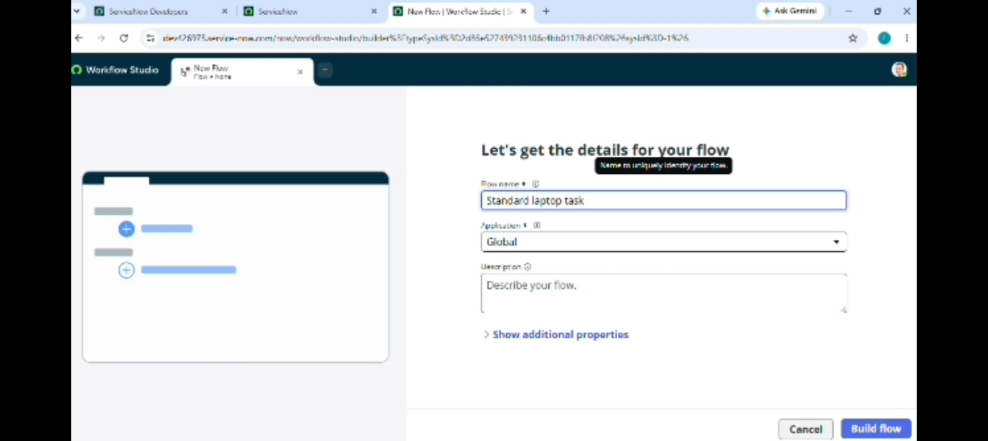

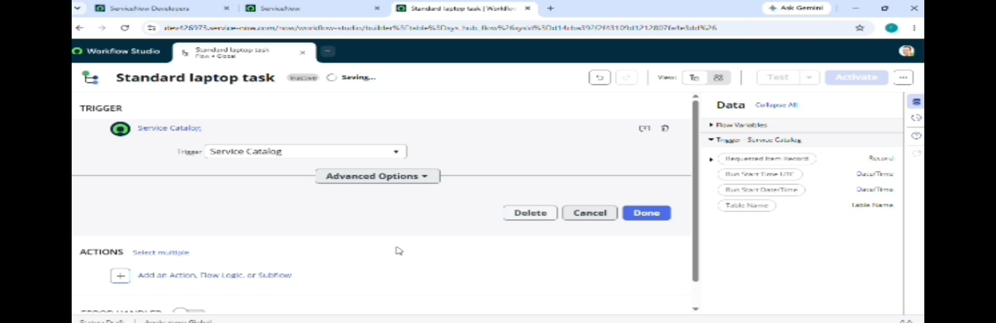

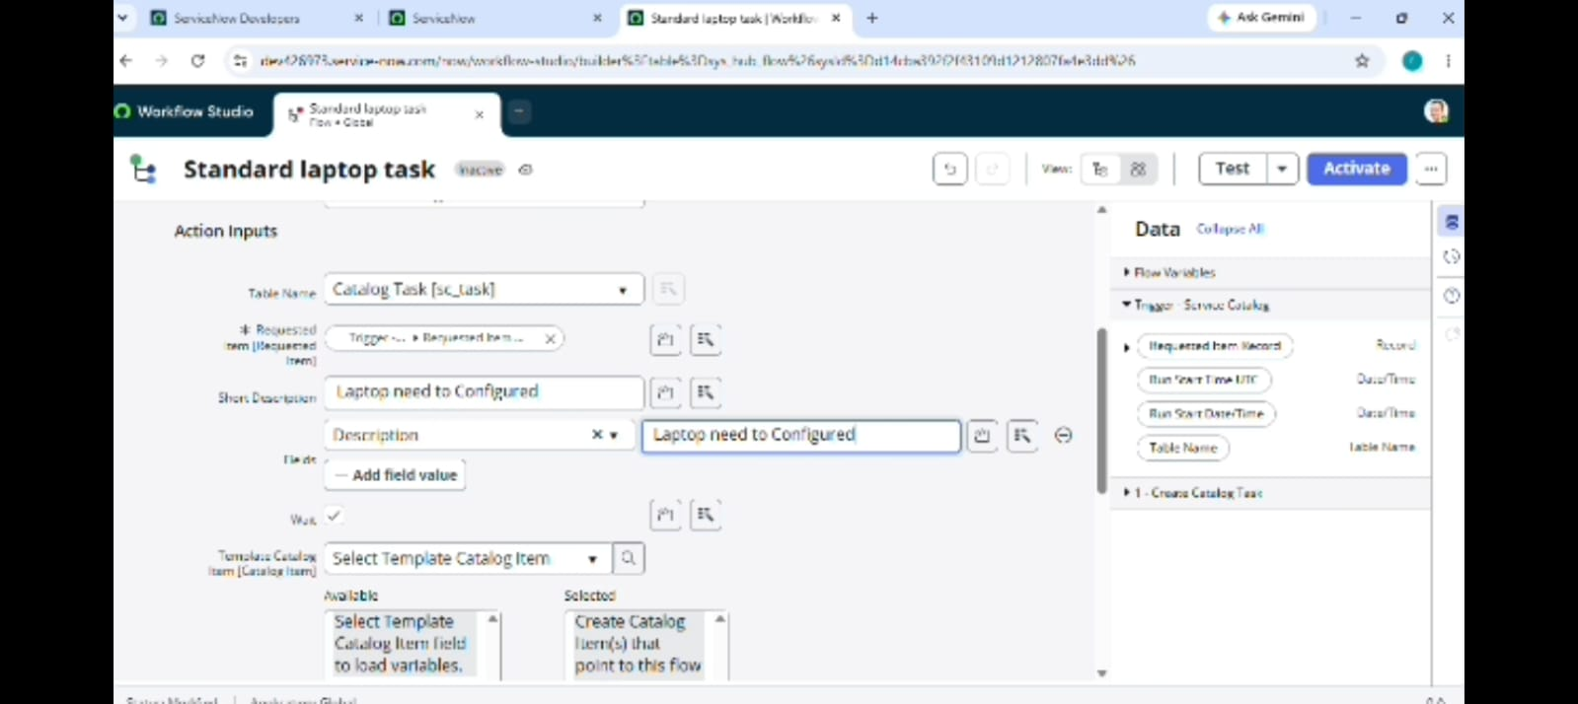

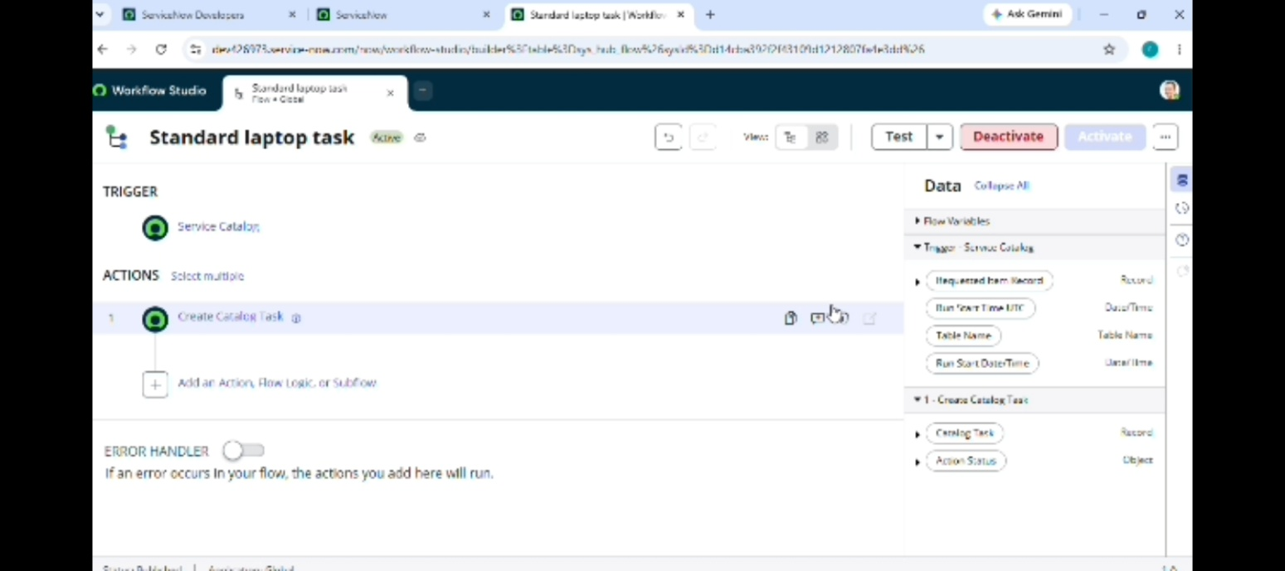
Milestone 2 – Flow Assignment:
The second milestone is to assign the created Flow to the Standard Laptop Service Catalog item.
Activity 1 – Assign Flow to Standard Laptop:
The planned activities are:
1. Open ServiceNow.
2. Select All.
3. Search for Maintain Items.
4. Open Maintain Items.
5. Search for Standard Laptop.
6. Select the Standard Laptop record.
7. Open the Process Engine section.
8. Remove the remaining automations as required.
9. Add the Flow.
10. Select the Flow named Standard Laptop Task.
11. Save the record.
This activity connects the created Flow with the Standard Laptop Service Catalog item.

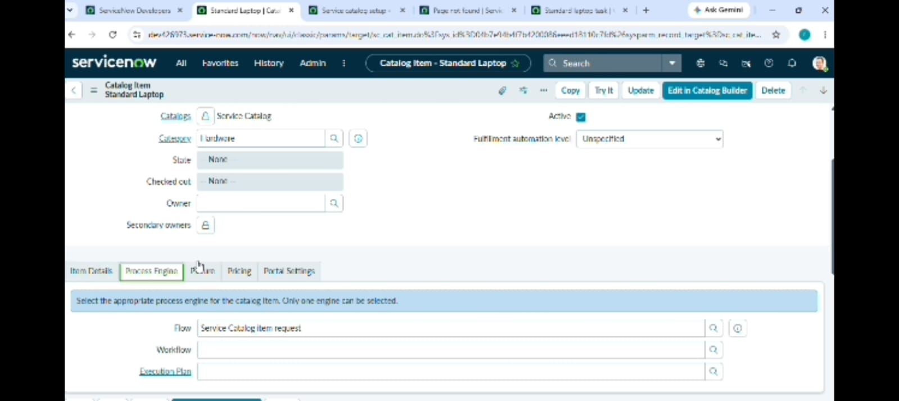
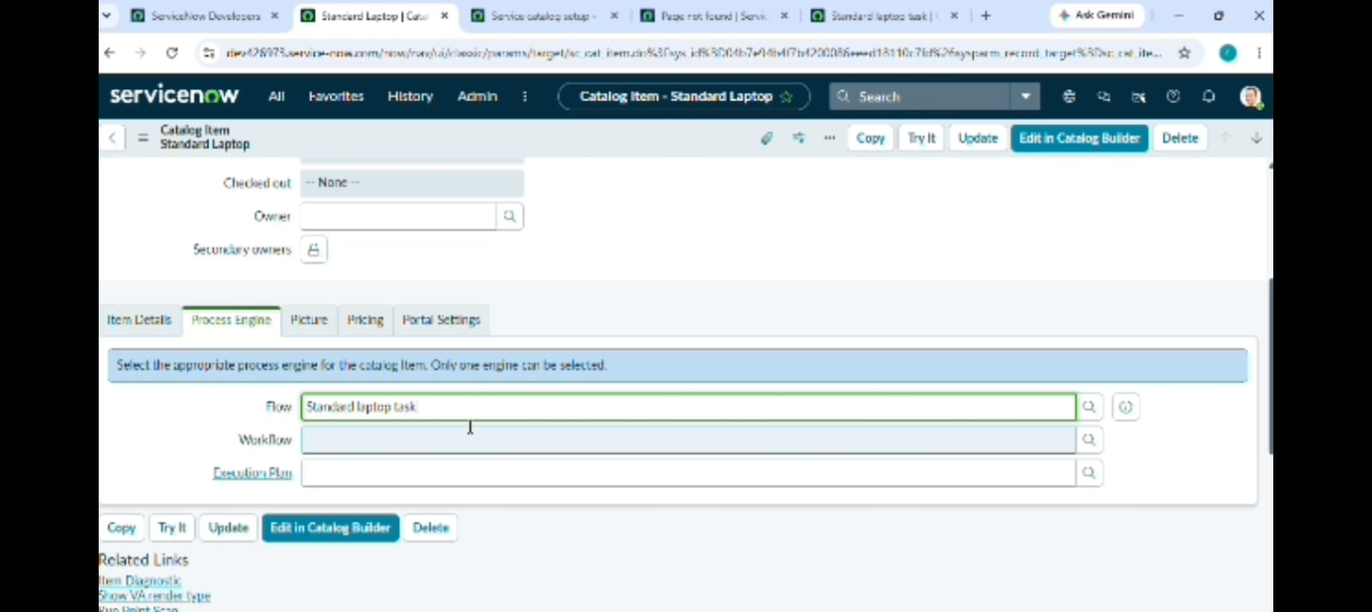
Milestone 3 – Service Catalog:
- The third milestone is to use the Standard Laptop Service Catalog item to place a request and complete the approval process.
Activity 1 – Place Standard Laptop Order:
The planned activities are:
1. Open Service Catalog.
2. Select Hardware.
3. Find Standard Laptop.
4. Open the Standard Laptop item.
5. Select Order Now.
6. View the Order Status.
7. Open the Request Number.

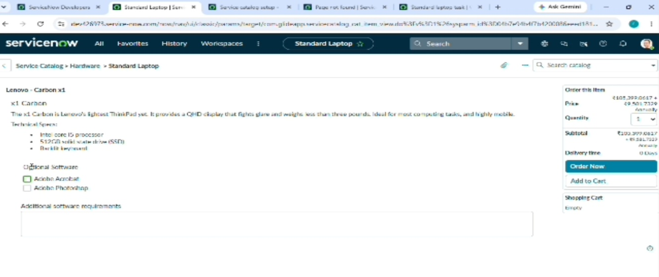
Approval Planning:
- After the Standard Laptop request is placed, the request record is opened.
- The Approvers section is accessed and the request is approved.
- The approval step is planned before checking the generated Catalog Task.
The planned sequence is:
  - Order Standard Laptop → Open Request Number → Approvers → Approve
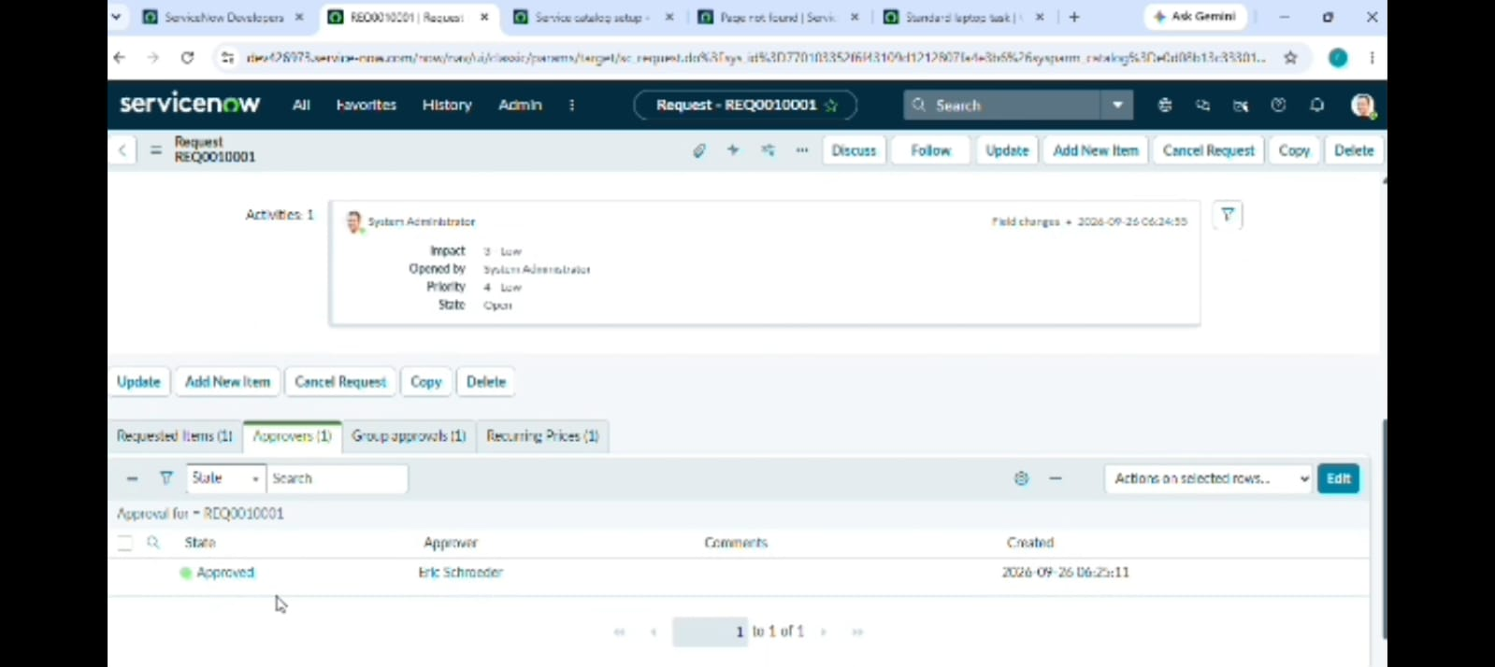

Catalog Task Verification Planning:
- After approval, the Requested Item record is opened.
- The Catalog Tasks section is then checked.
The generated task should display the required information, including:
- Updated status
- Short description
- Assigned group
The expected configured values are:
- Short Description: Laptop need to Configured
- Assignment Group: Hardware
This step is planned to verify that the Flow has generated the required task correctly.
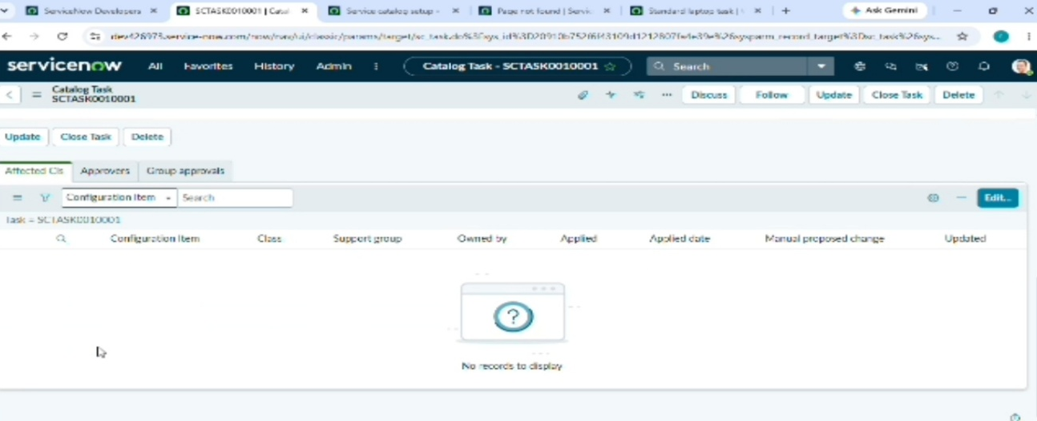

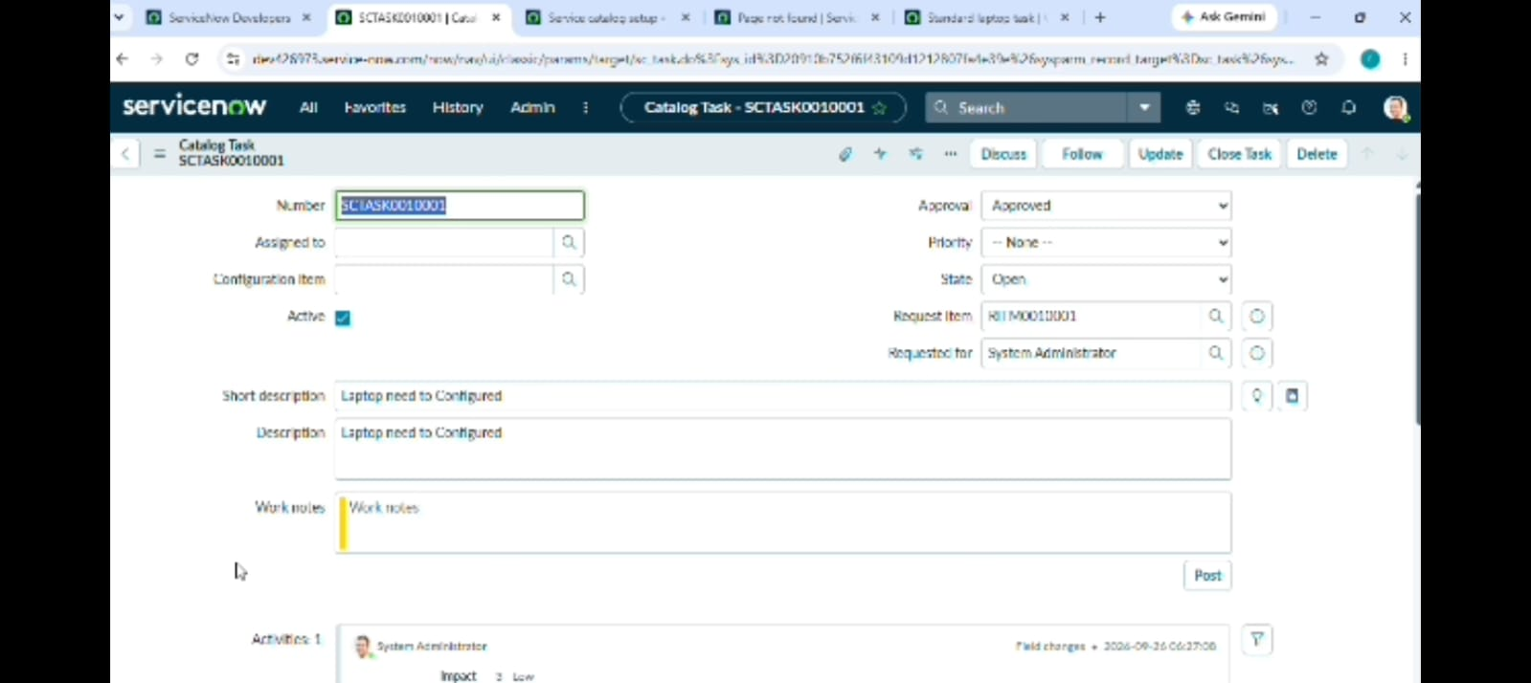

Project Activity Sequence:
The complete project activity sequence is planned as follows:
Stage 1 – Flow Creation
Create Flow → Configure Trigger → Configure Action → Save → Activate
↓
Stage 2 – Flow Assignment
Maintain Items → Standard Laptop → Process Engine → Add Standard Laptop Task Flow → Save
↓
Stage 3 – Service Catalog Request
Service Catalog → Hardware → Standard Laptop → Order Now
↓
Stage 4 – Approval
Request Number → Approvers → Approve
↓
Stage 5 – Task Verification
Requested Item → Catalog Tasks → Open Generated Task
This sequence provides a clear order for carrying out the project activities.
Project Planning Components:
The main components planned for the project are:
1. ServiceNow Platform
2. Flow Designer
3. Standard Laptop Service Catalog Item
4. Service Catalog Trigger
5. Create Catalog Task Action
6. Maintain Items
7. Process Engine
8. Approval Process
9. Catalog Task
10. Hardware Assignment Group
These components are used in different stages of the planned implementation.

Milestone Summary:

Milestone | Main Activity | Planned Output
Milestone 1 | Flow Creation | Activated Standard Laptop Task Flow
Milestone 2 | Flow Assignment | Flow assigned to Standard Laptop
Milestone 3 | Service Catalog | Request, approval and generated Catalog Task

This table can be included in the Phase 4 document because it gives a simple summary of the project plan.
Project Workflow Plan:
The overall project plan can be represented as:
Start
↓
Create Standard Laptop Task Flow
↓
Configure Service Catalog Trigger
↓
Configure Create Catalog Task Action
↓
Save and Activate Flow
↓
Assign Flow to Standard Laptop
↓
Place Standard Laptop Order
↓
Approve Request
↓
Check Generated Catalog Task
↓
Verify Hardware Assignment and Short Description
↓
End
Phase 4 Summary:
- The Project Planning phase organizes the implementation of the Standard Laptop procurement automation into three main milestones.
- The first milestone focuses on creating and activating the Flow. The second milestone assigns the Flow to the Standard Laptop Service Catalog item. The third milestone focuses on placing the Standard Laptop request, completing the approval process, and checking the generated Catalog Task.
- This planned sequence provides a structured approach for carrying out the project implementation and verifying the automated workflow

